EVENT MANAGEMENT SYSTEM
“ Momento ”

Submitted By :

Mihir Vaidya ( 202504104610024 ) Vivek Gosai ( 202504104610023 ) Chirag Modi ( 202504104610142 ) Viraj Patel ( 202504104610086 )

Guided By:
Ms. Shivani Talaviya

For partial fulfilment of the requirements For the Degree of Master of Computer Application,
Shrimad Rajchandra Institute of Management and Computer Application Uka Tarsadia University
Feb , 2026

DECLARATION
We hereby declare that the project titled Event Management System is fully implemented by us. It is neither paid nor copied. Even though, later on, in case of any infringement found for this project work, we are solely responsible for the same and understand that as per UGC norms, the University can revoke the degree conferred to us.

Enrollment No | Students Name | Signature
202504104610024 | Mihir Vaidya
202504104610023 | Vivek Gosai
202504104610142 | Chirag Modi
202504104610086 | Viraj Patel

As a guide, I assure you that there is no plagiarism found in the submitted document.

Guide Name: Ms. Shivani Talaviya Signature:
Date: Place: SRIMCA ,UTU

Acknowledgement

It is my privilege to express my sincere gratitude to the individuals who helped me, directly or indirectly, in conducting this project work. I would like to thank Uka Tarsadia University for including this project work activity in the M.C.A. curriculum.

I am deeply grateful to our Director, Dr. Dharmendra Bhatti, and my project guide, Ms. Shivani Talaviya for providing the valuable guidance and suggestions necessary for the successful completion of this project. I am also indebted to all the respondents, whose cooperation made this project possible.

Finally, I extend my special thanks to every faculty member of the Shrimad Rajchandra Institute of Management and Computer Application (SRIMCA), as well as my friends and family, for their constant support throughout this endeavour.

INDEX

Chapter 1 : Introduction of System 1
  - Problem Statement 6
  - Solution for Problem Statement 7
  - Proposed Solution 7
  - Objectives of the System 7
  - System Scope 8
  - System Limitations 8
  - Tools and Technologies Used 9
Chapter 2 : System Analysis 10
  - Functional Requirements 10
  - Data Model Description 11
Chapter 3 : Conceptual Diagram 14
  - Use Case Diagram 14
    - User 14
    - User 15
    - Admin 16
  - Activity Diagram 16
    - Activity Diagram for Login / Registration 16
    - Activity Diagram of Browsing Package 17
    - Activity Diagram of Booking Package 18
    - Custom Flow For Product……………………………………………………………20
    - Booking Flow For Package………………………………………………………….21
    - Product Booking Flow………………………………………………………………..22

Chapter 4 : System Design 23
  - Database Design 23
    - Event Collection 23
    - Package Collection 25
    - User Collection 27
    - Booking Collection…………………………………………………………………….28
    - Categories Collection…………………………………………………………………30
    - ProductBooking Collection………………………………………………………….31
4.1.7 Product Collection……………………………………………………………………..33
  - API Screenshots 38
    - Event API 38
    - Package API 39
  - User Interface Design 40
    - Home Page 40
    - Recent Events 41
    - Custom Events…………………………………………………………………………….42
    - Product Details……………………………………………………………………………43
    - Package Display 44
    - Package Detail 45
    - About Us 46
    - Contact Us 47
    - Login 48
    - Registration 48
    - Admin Dashboard ………………………………………………………………………….49
    - User Display …………………………………………………………………………………….49
Chapter 5 : Future Enhancement ……………………………………………………………
Future Scope …………………………………………………………………………………………..52
Chapter 6 : learning and Development ……………………………………………………
Learing …………………………………………………………………………………………………..53

Chapter 1 : Introduction Of System

Problem Statement
Event planning and management is a complex process that requires coordination of various services such as venue booking, catering, decoration, and scheduling. Traditional event management methods rely on manual processes, phone calls, and physical booking systems, which are time-consuming, inefficient, and prone to errors.

There is a need for an automated system that allows users to explore event packages, view details, and book events easily from a single platform. The system should also manage user registration, event packages, and booking information efficiently.

The proposed Event Management System (Momento) provides a digital platform that simplifies event planning by offering event packages, booking functionality, and centralized management.

The proposed solution is a web-based Event Management System that provides:
    - Online event browsing
    - Event package selection
    - User registration and login
    - Package details viewing
    - Event booking functionality
    - Centralized database management

Solution for Problem Statement
The proposed solution is a web-based Event Management System that provides:
    - Online event browsing
    - Event package selection
    - User registration and login
    - Package details viewing
    - Event booking functionality
    - Centralized database management
    - Make a custom Event
The system reduces manual work and provides a simple and efficient way to manage events.

Proposed Solution
The proposed system is a web-based platform that provides:
    - Online event package browsing
    - User authentication and registration
    - Package details with images and catering information
    - Event booking functionality
    - Centralized data storage
    - Secure backend services
The system reduces manual work and improves efficiency by digitizing the event management process.

Objectives of the System
The main objectives of the Event Management System are:
    - To provide an online event booking platform
    - To simplify event package selection
    - To manage user accounts securely
    - To maintain centralized database of events and users
    - To provide easy access to event information

    - To reduce manual workload in event planning
    - To improve user experience using modern UI design

System Scope
The scope of the system includes:
    - User registration and login
    - Viewing event packages
    - Viewing package details
    - Event booking functionality
    - Data storage in MongoDB database
    - Backend API integration
    - Authentication
    - Verify Register User

Future Scope :
    - Online payment integration
    - Admin dashboard
    - Email notifications
    - Event scheduling management

System Limitations :
    - No payment gateway integration
    - No advanced admin panel
    - Limited booking management
    - No event cancellation feature
    - No notification system
    - No multi-user role management

Tools and Technologies Used

Frontend Technologies :

    - React.js — Component-based UI development

    - HTML5 — Page structure

    - CSS3 — Styling and layout

    - JavaScript — Dynamic functionality

Backend Technologies :

    - Node.js — Server runtime environment

    - Express.js — REST API framework

Database :

    - MongoDB — NoSQL document-based database

    - Mongoose — MongoDB object modeling

Development Tools :

    - Visual Studio Code

    - Thunder Client API testing

    - GitHub version control

CHAPTER 2 — SYSTEM REQUIREMENTS

Functional Requirements

User Management

    - User registration

    - User login authentication

    - Password encryption

    - Session handling

Event Management

    - View event packages

    - View package details

    - Display package images

    - Display catering services

Booking Management

    - Book selected event

    - Store booking details

    - Associate booking with user

Database Management

    - Store user records

    - Store Event Packages

    - Retrieve Data dynamically

Data Model Description
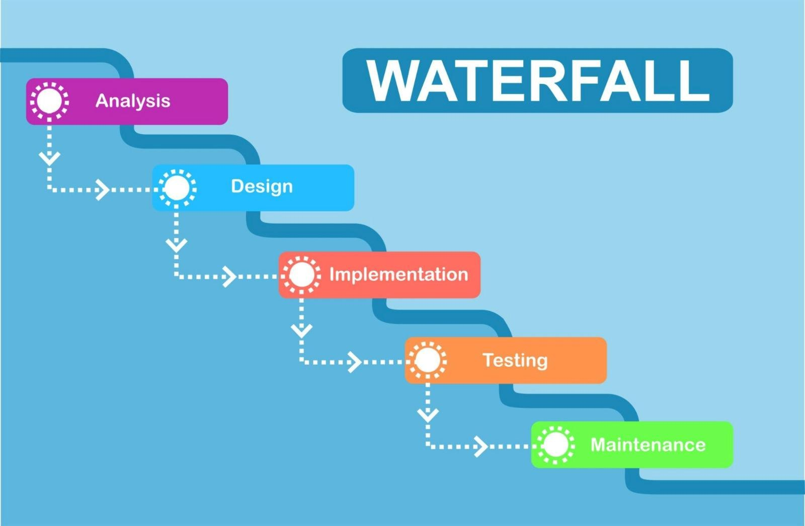

The Waterfall Model is a linear and sequential software development process where each phase must be completed before moving to the next. This model is suitable for the Event Management System because the project requirements, system design, and expected functionalities were clearly defined before implementation.
The Waterfall Model is a linear and sequential software development process where each phase must be completed before moving to the next. This model is suitable for the Event Management System because the project requirements, system design, and expected functionalities were clearly defined before implementation.

Phases of Waterfall Model Applied in the Project

Requirement Analysis

In this phase, the requirements of the Event Management System were identified. The system needed to allow users to register, log in, view event packages, and book events. The administrator required functionality to manage events, packages, and users.

System Design

During the design phase, the overall structure of the system was planned. UML diagrams such as Use Case Diagrams, Activity Diagrams, and Data Models were created to represent the system architecture and interaction between components. The database structure was also designed using MongoDB collections.

Implementation

In this phase, the actual development of the system took place. The project was implemented using the MERN stack (MongoDB, Express.js, React.js, Node.js). Frontend interfaces were developed using React, while backend APIs were implemented using Node.js and Express.js to handle authentication, package management, and booking operations.

Testing

After implementation, the system was tested to ensure all functionalities worked correctly. Testing included checking user authentication, booking validation, package display, and database operations to verify that the system behaved as expected.

Deployment and Maintenance

In the final phase, the application was executed and demonstrated as a complete working system. Any minor errors discovered during testing were corrected to improve system performance and reliability.

Conclusion

The Waterfall Model was selected for the Event Management System because it provides a structured development approach with clearly defined phases. Since the project requirements were well understood from the beginning and the scope remained stable throughout development, the Waterfall model helped in organizing the development process and maintaining proper documentation for the project

CHAPTER 3 — CONSEPTUAL DESIGN

Use Case Diagram

Actors :
    - User (Booking Package)
    - User (Custom event Booking)
    - Admin

User

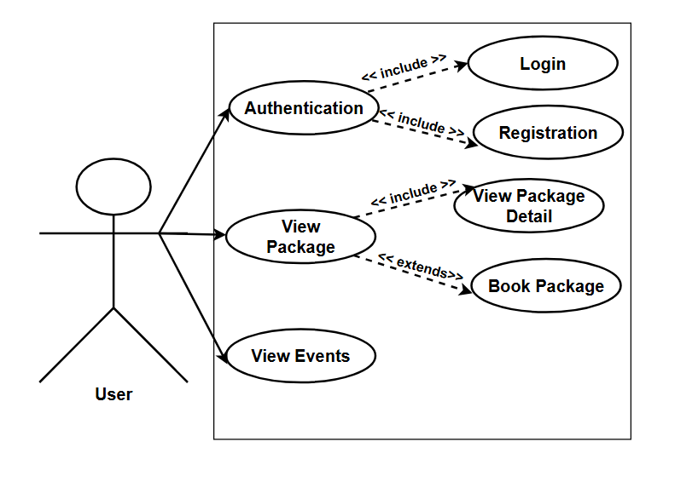

      - User can Login but first he have to register through Registration Page
      - User can View Packages .
      - User also view Event that are recently organized by Momentoe.

    - User (Custom event Booking)

<<include>> : Use <<include>> when a use case always performs another use case as part of its process.
<<extends>> : Use <<include>> when a use case always performs another use case as part of its process.

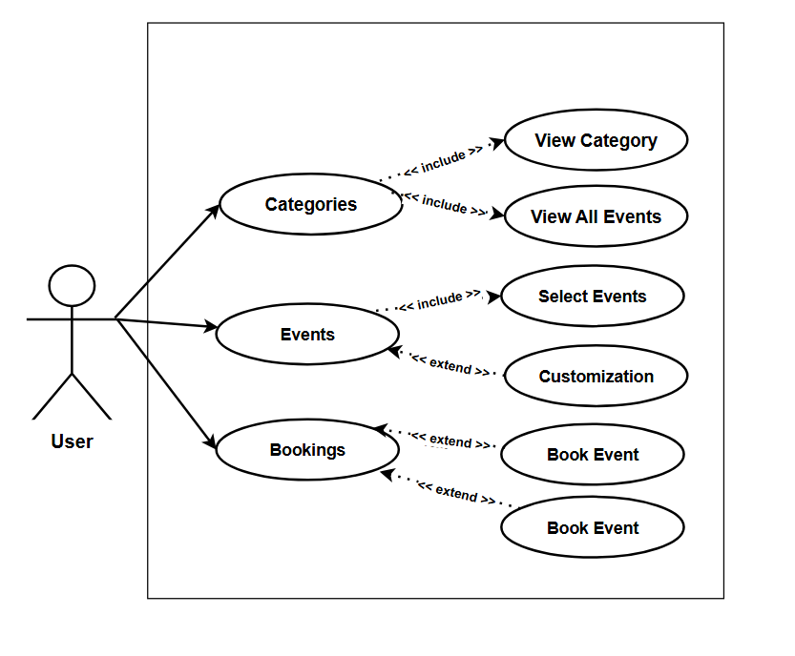

3.1.3 Admin :

<<include>> : Use <<include>> when a use case always performs another use case as part of its process.
<<extends>> : Use <<include>> when a use case always performs another use case as part of its process.

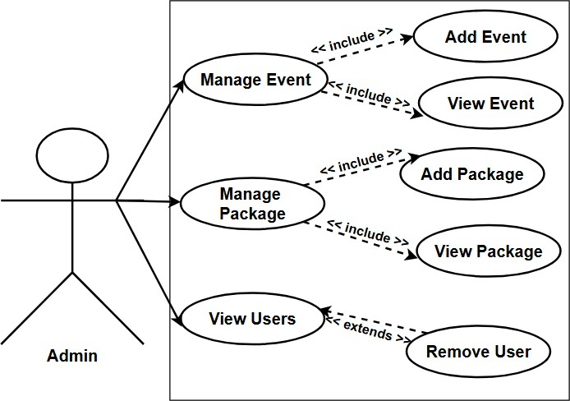

      - Admin View Packages
      - Admin View Events
      - Admin View User
      - Admin manage Events
      - Admin manage Packages

Activity Diagram :

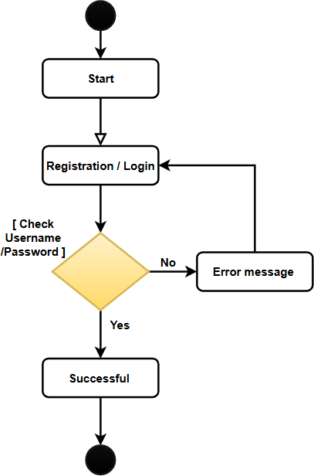
Activity Diagram for Login / Registration :

Activity Diagram of Browsing Package :

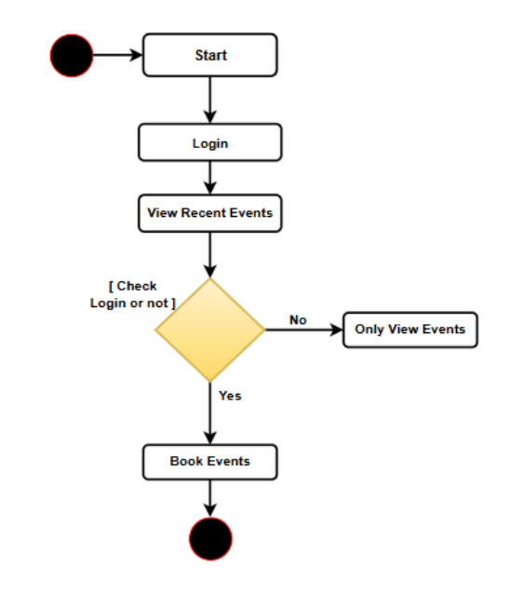

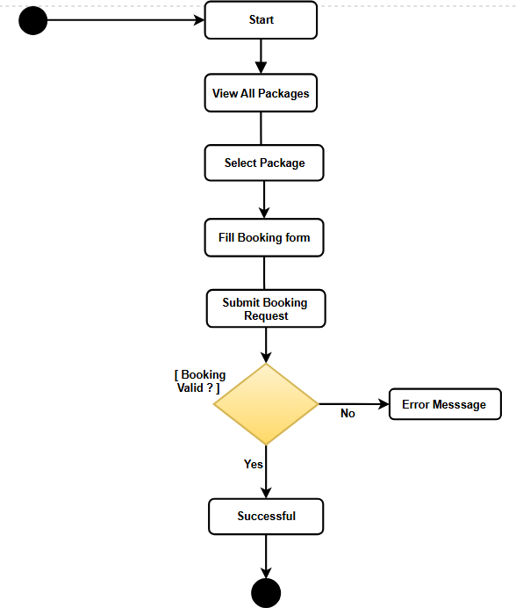
Activity Diagram of Booking Package :

Custom Product :

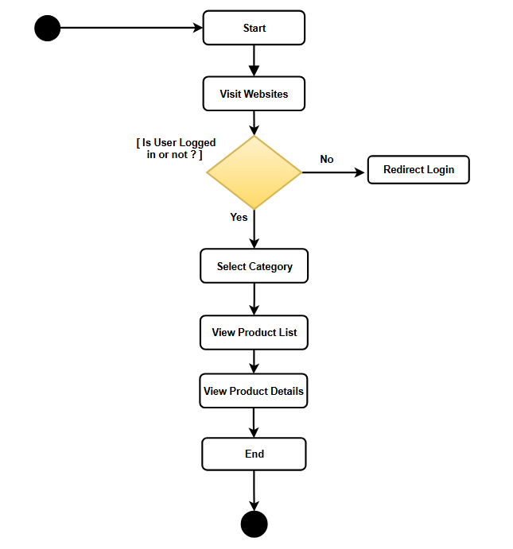

Booking Flow :

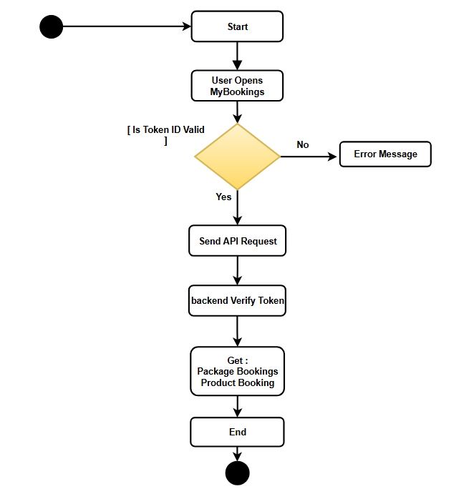

3.4.6 Product Booking Flow :

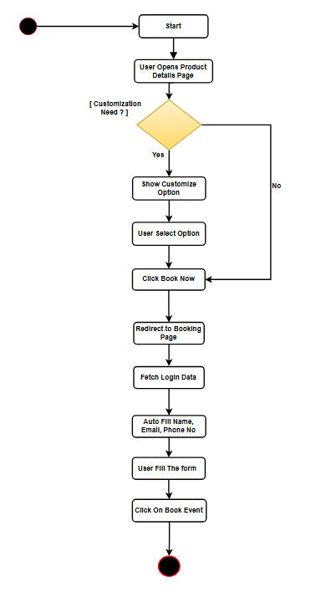

CHAPTER 4 — SYSTEM DESIGN

Database Design :

Event Collection

Field | Field Type | Constraints | Description
id | ObjectId | Primary Key,  Auto-generated | Unique identifier for each  event document.
title | String | Required, Not Null | Stores the name or title of  the event.
description | String | Required | Provides details about the  event.
date | Date | Required | Stores the date on which the  event will take place.
location | String | Required | Stores the venue or location  of the event.
image | String | Optional | Stores the image file name  or URL related to the event.
createdAt | Date | Default: Current Date | Records the date and time when the event was created.
updatedAt | Date | Auto Updated | Records the date and time when the event details were  last updated.

MongoDB Design Approach

      - Document-based storage

      - Flexible schema

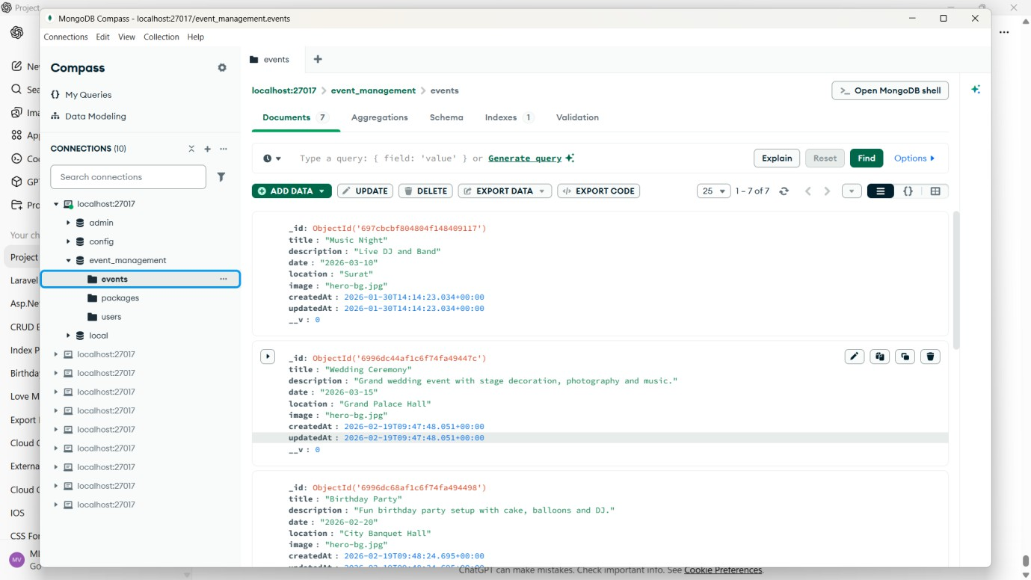
Event Collection :

Package Collection :

Field | Fild type | Constreint | Description
id | ObjectId | Primary Key, Auto-  generated | Unique identifier for each package  document.
name | String | Required, Not Null | Stores the name of the event package.
description | String | Required | Provides details about the services included in the package.
price | Number  (Integer) | Required, Minimum  Value | Stores the cost of the event package.
startDate | Date | Required | Indicates the starting date of the package availability.
endDate | Date | Required | Indicates the ending date of the  package availability.
images | Array | Optional | Stores image URLs or file paths related to the package.
catrering | Array | Optional | Stores catering items or food services included in the package.
createdAt | Date | Default: Current Date | Records the date and time when the package was created.
updatedAt | Date | Auto Updated | Records the date and time when the package details were last updated.

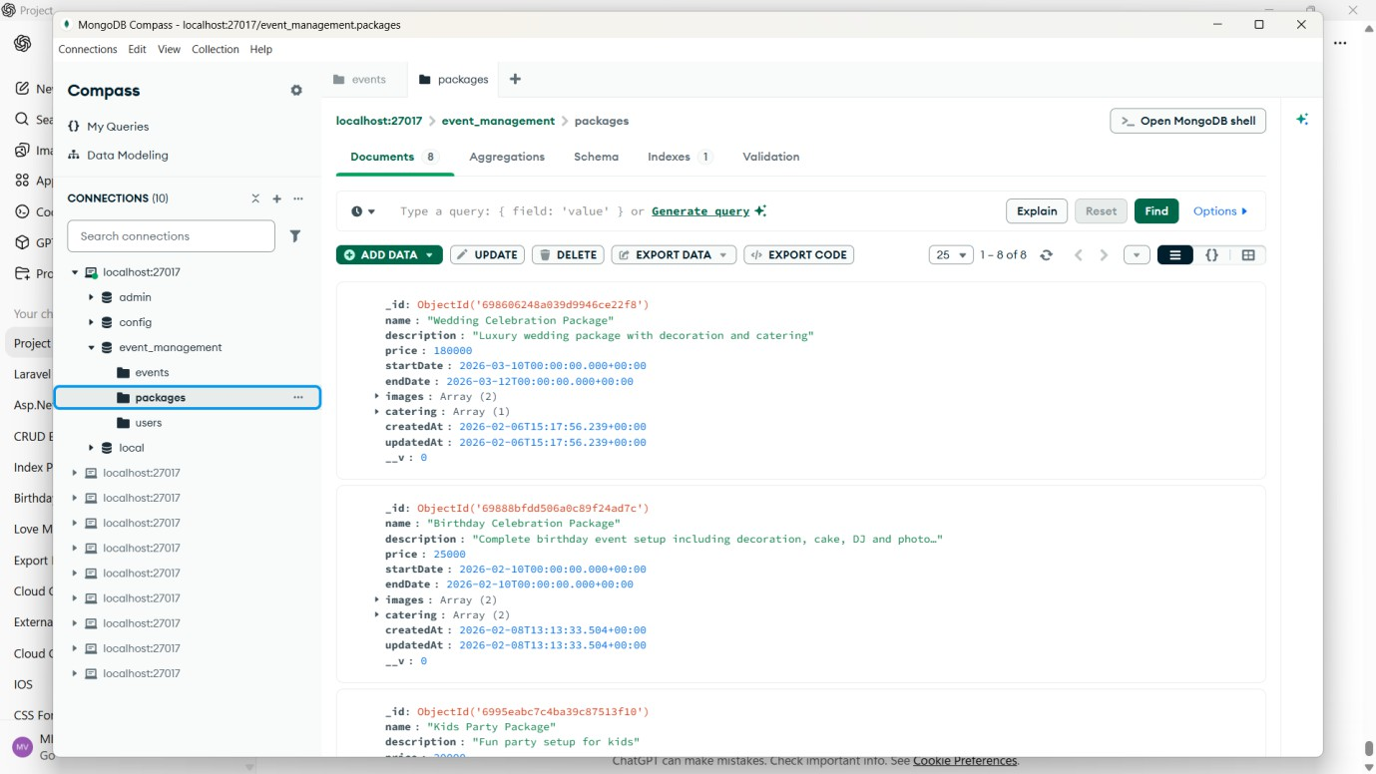
Package Collection :

User Collection :

Field | Field type | Constraint | Description
Id | ObjectId | Primary Key, Auto-  generated, Required | Unique identifier for each  user document.
fullname | String | Required, Not Nul | Stores the full name of the  user.
email | String | Required, Unique | Stores the user’s email  address used for login and communication.
password | String | Required | Stores the encrypted/hashed  password of the user.
phone | String | Required | Stores the user’s contact  phone number.
createdAt | Date | Default: Current Date | Records the date and time when the user account was  created.
updatedAt | Date | Auto Updated | Records the date and time  when the user information was last updated.

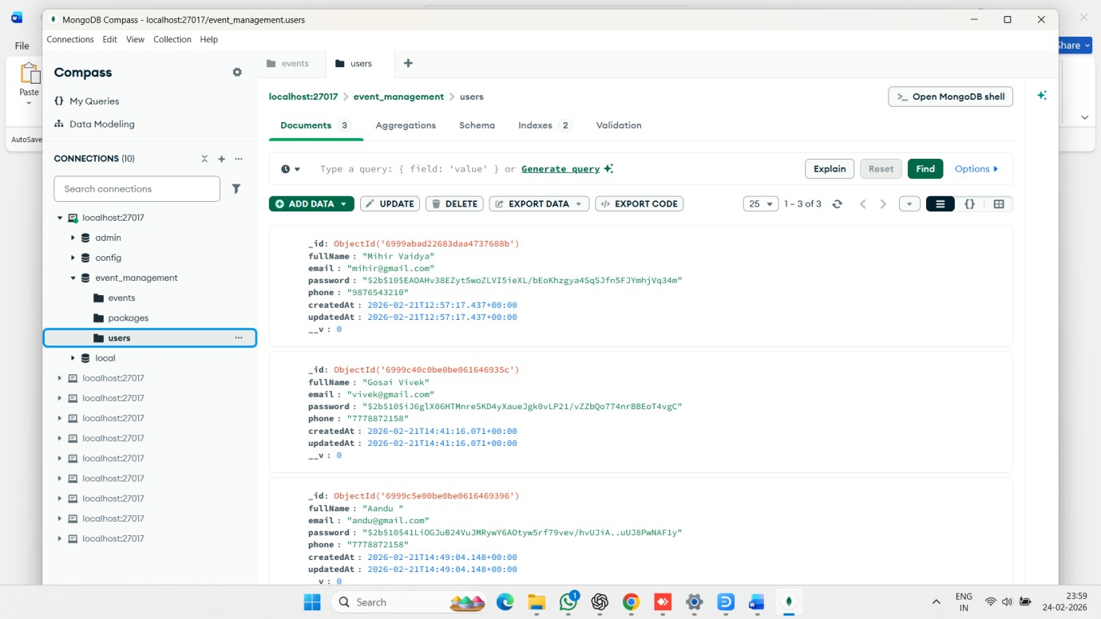
User Collection :

4.1.4 Bookings Collection:

Field | Field type | Constraint | Description
_id | ObjectId | Primary Key, Auto-generated, Required |  | Uniqueidentifier for each booking document.
userId | ObjectId | Required, Foreign Key (References Users Collection) |  | Stores the unique ID of the user who made the booking.
userName | String | Required |  | Stores the full name of the user who made the booking.
email | String | Required |  | Stores the email address of the user for booking communication and confirmation.
packageId | ObjectId | Required, Foreign Key (References Packages Collection) |  | Stores the unique ID of the selected event package.
startingDate | Date | Required |  | Stores the booking start date of the event.
endingDate | Date | Required |  | Stores the booking end date of the event.
location | String | Required |  | Stores the event location selected by the user.
phoneNumber | String | Required |  | Stores the contact number of the user for communication.
guestCount | Number | Required, Minimum Value: 1 |  | Stores the number of guests attending the event.
specialRequest | String | Optional / Default: "" |  | Stores any additional special requests or notes provided by the user.
createdAt | Date | Default: Current Date |  | Records the date and time when the booking was created.
updatedAt | Date | Auto Updated |  | Records the date and time when the booking information was last updated.
__v | Number | Default: 0, Auto-generated by Mongoose |  | Internal version key used by Mongoose for document versioning.

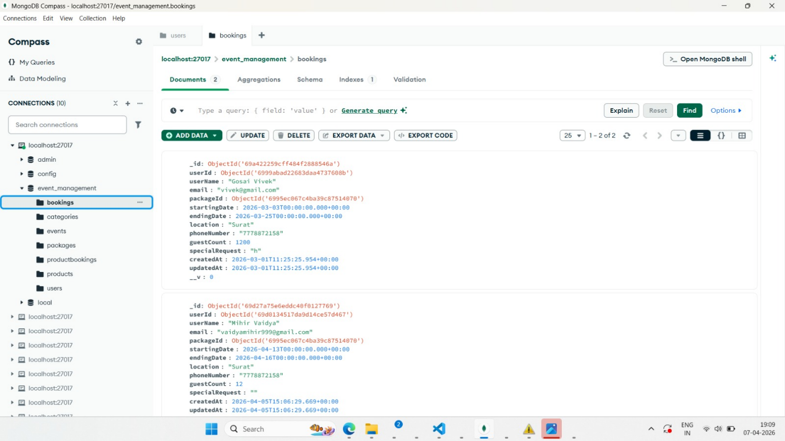

4.1.5 Categories Collection:

Field | Field type | Constraint | Description
_id | ObjectId | Primary Key, Auto-generated, Required | Unique identifier for each category document.
name | String | Required, Unique | Stores the name of the event category (e.g., Mandap, Reception, Birthday Party, Engagement).
image | String | Required | Stores the image file name or path associated with the category.
__v | Number | Default: 0, Auto-generated by Mongoose | Internal version key used by Mongoose for document versioning.

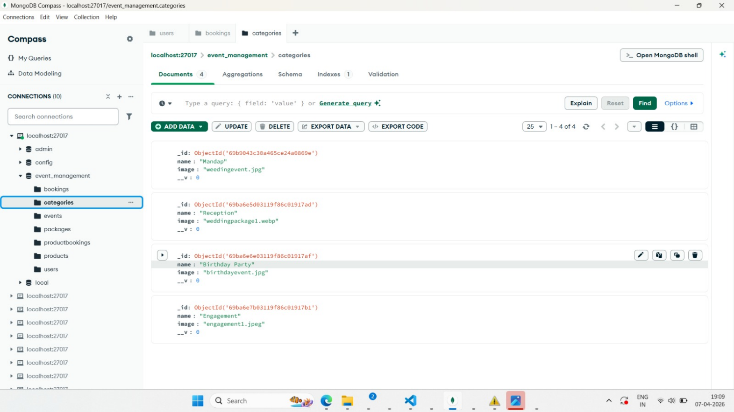

4.1.6 ProductBookings Collection:

Field | Field type | Constraint | Description
_id | ObjectId | Primary Key, Auto-generated, Required | Unique identifier for each product booking document.
userId | ObjectId | Optional / Foreign Key (References Users Collection) | Stores the unique ID of the user who made the product booking.
userName | String | Required | Stores the name of the user who booked the product.
email | String | Required | Stores the email address of the user for booking communication.
phoneNumber | String | Required | Stores the contact number of the user.
productId | ObjectId | Required, Foreign Key (References Products Collection) | Stores the unique ID of the selected product.
productName | String | Required | Stores the name of the booked product.
price | Number | Optional / Required (if stored) | Stores the price of the selected product at the time of booking.
customizations | Object | Optional | Stores customization details selected by the user for the product booking.
date | Date / String | Required | Stores the booking or event date for the product.
location | String | Required | Stores the event or delivery location for the booked product.
guestCount | Number | Required | Stores the number of guests related to the product booking.
specialRequest | String | Optional / Default: "" | Stores any additional requests or notes from the user.
createdAt | Date | Default: Current Date | Records the date and time when the product booking was created.
updatedAt | Date | Auto Updated | Records the date and time when the product booking was last updated.
__v | Number | Default: 0, Auto-generated by Mongoose | Internal version key used by Mongoose for document versioning.

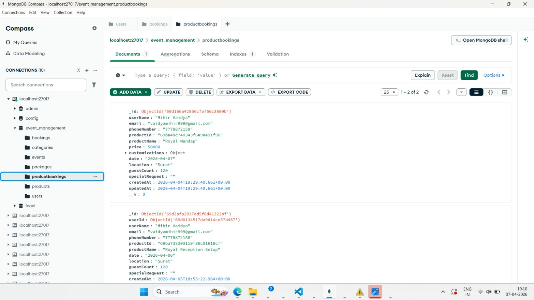

4.1.7 Products Collection:

Field | Field type | Constraint | Description
_id | ObjectId | Primary Key, Auto-generated, Required | Unique identifier for each product document.
name | String | Required | Stores the name of the product (e.g., Royal Mandap, Classic Wedding Mandap, Luxury Designer Mandap).
price | Number | Required | Stores the price of the product.
image | String | Required | Stores the image file name or path associated with the product.
description | String | Required | Stores the description/details of the product.
categoryId | ObjectId | Required, Foreign Key (References Categories Collection) | Stores the unique ID of the category to which the product belongs.
customizations | Array | Optional | Stores the available customization options for the product.
default | Array | Optional / Default: Empty Array | Stores default customization values or options for the product.
__v | Number | Default: 0, Auto-generated by Mongoose | Internal version key used by Mongoose for document versioning.

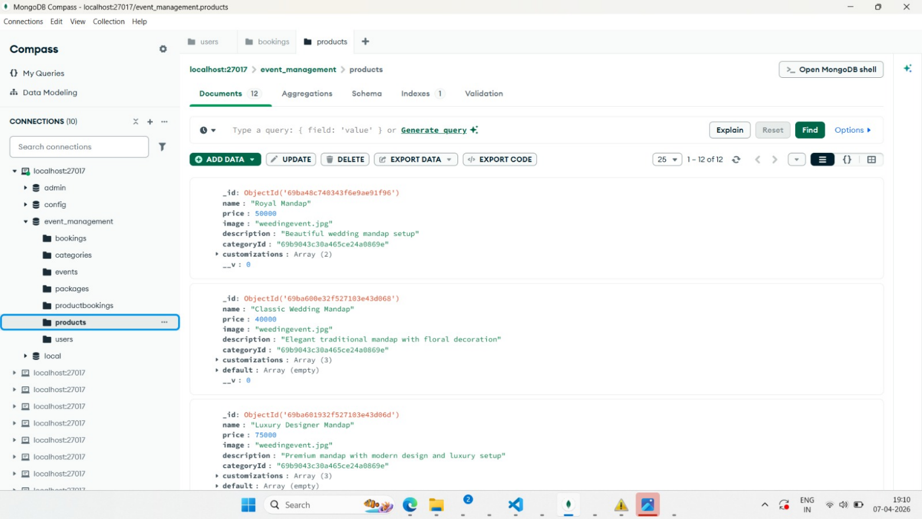

Event Document :

{

"_id": {

"$oid": "697cbcbf804804f148409117"

},

"title": "Music Night", "description": "Live DJ and Band", "date": "2026-03-10",
"location": "Surat",

"image": "hero-bg.jpg", "createdAt": {
"$date": "2026-01-30T14:14:23.034Z"

},

"updatedAt": {

"$date": "2026-01-30T14:14:23.034Z"

},

" ": 0

}

Package Collection Document :

{

"_id": {

"$oid": "698606248a039d9946ce22f8"
},
"name": "Wedding Celebration Package",

"description": "Luxury wedding package with decoration and catering", "price": 180000,
"startDate": {

"$date": "2026-03-10T00:00:00.000Z"

},

"endDate": {

"$date": "2026-03-12T00:00:00.000Z"

},

"images": [

"hero-bg.jpg",

"hero-bg.jpg"

],

"catering": [

{

"thaliName": "Premium Wedding Thali",

"description": "Paneer, Dal Makhani, Butter Naan, Sweet", "price": 1500,
"_id": {

"$oid": "698606248a039d9946ce22f9"

}

}

],

"createdAt": {
"$date": "2026-02-06T15:17:56.239Z"

},

"updatedAt": {

"$date": "2026-02-06T15:17:56.239Z"

},

" ": 0

}

User Collection Document :

{

"_id": {

"$oid": "6999abad22683daa4737608b"

},

"fullName": "Mihir Vaidya",

"email": "mihir@gmail.com",

"password": "$2b$10$EAOAHv38EZyt5woZLVI5ieXL/bEoKhzgya4SqSJfn5FJYmhjVq34m",
"phone": "9876543210",

"createdAt": {

"$date": "2026-02-21T12:57:17.437Z"
},

"updatedAt": {

"$date": "2026-02-21T12:57:17.437Z"

},

" ": 0

API Screenshots :

    - Events :
    - packages :

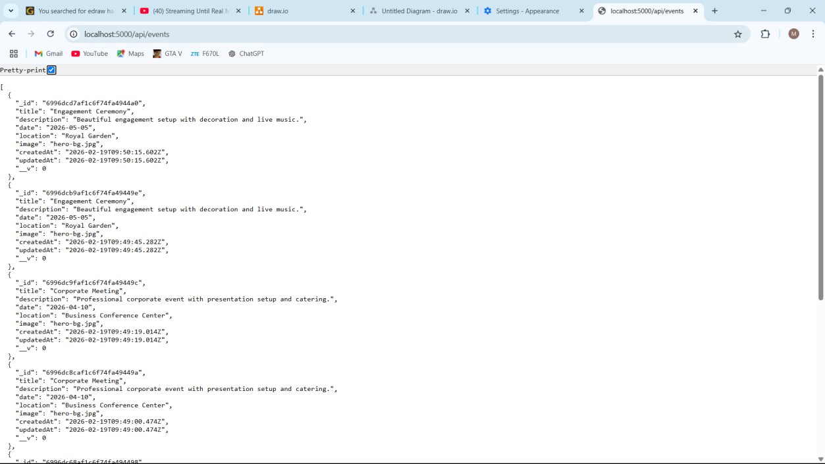
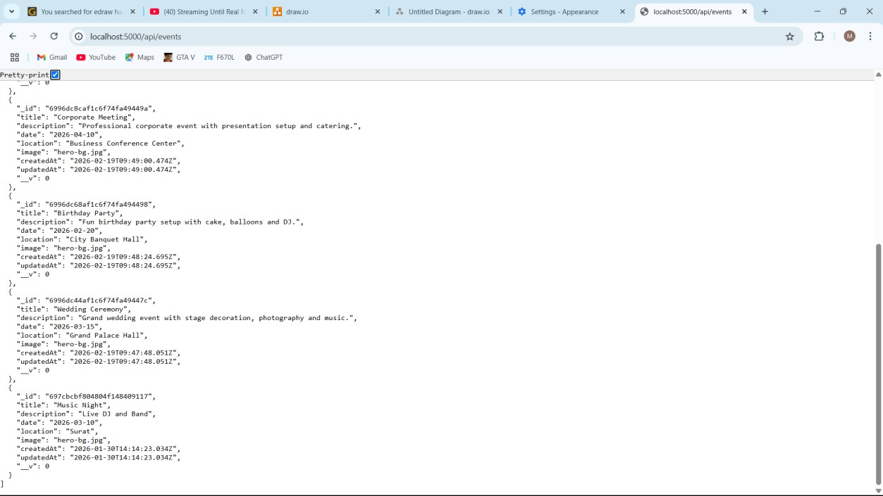
    - Events :

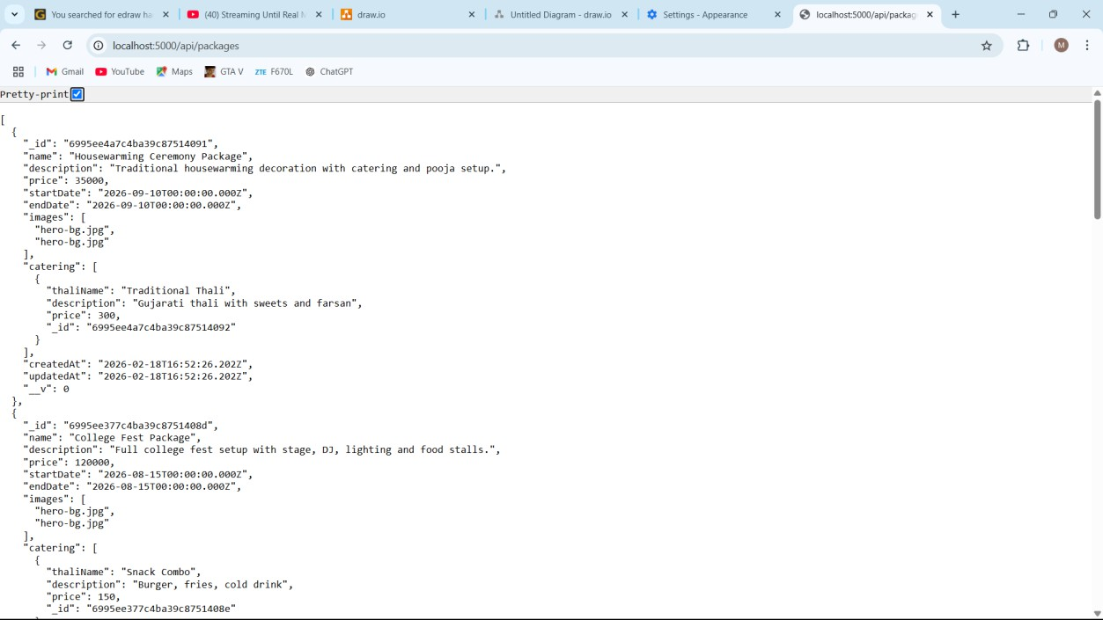
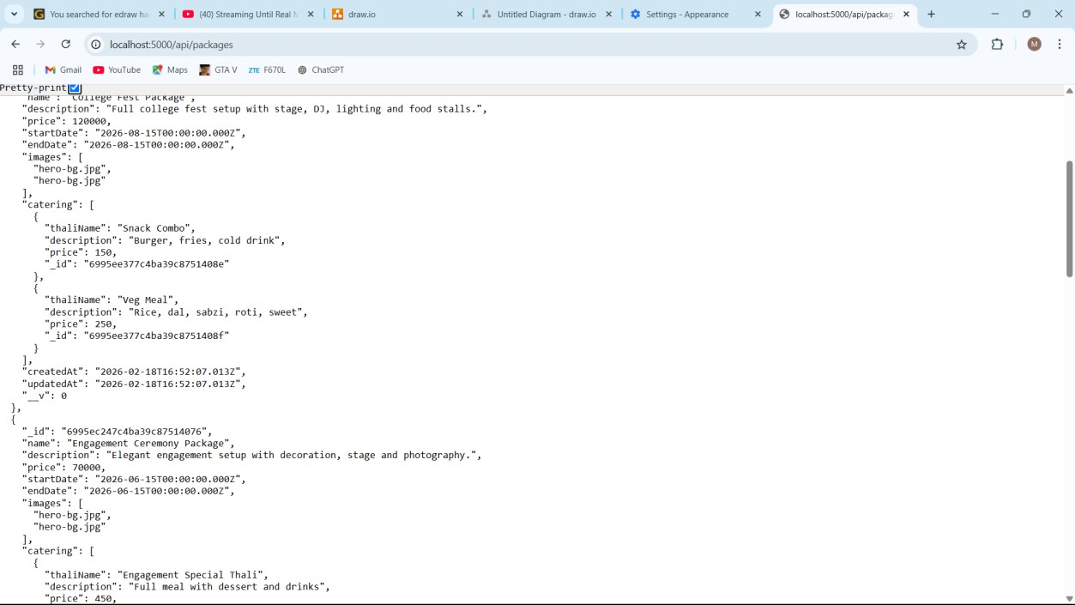
4.2.2 Packages :

Frontend Design :

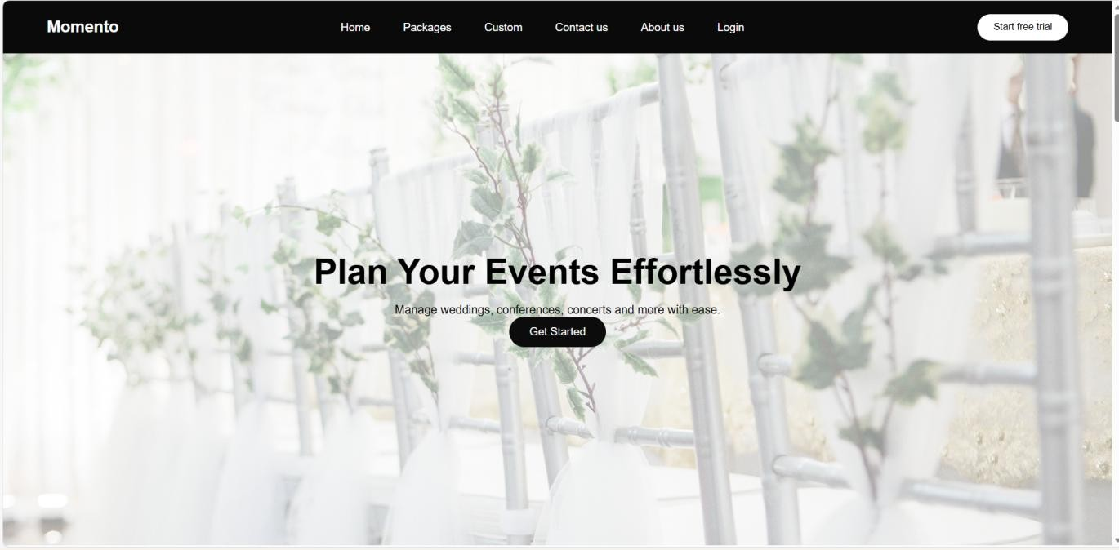
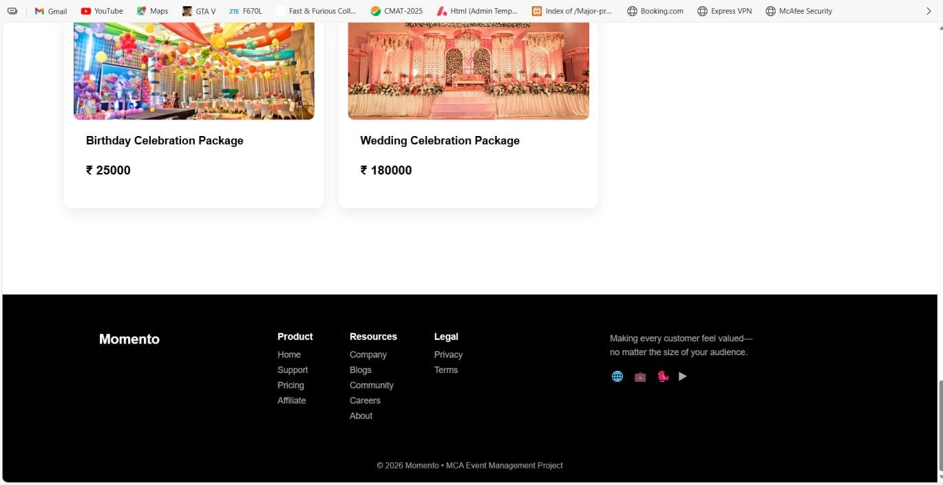
Home Page

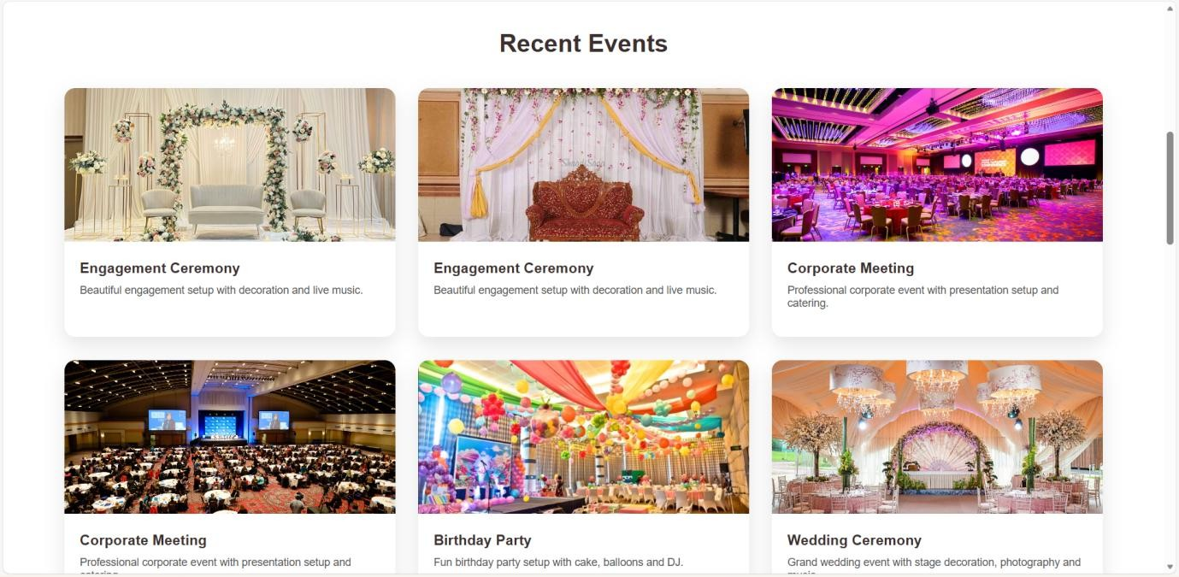
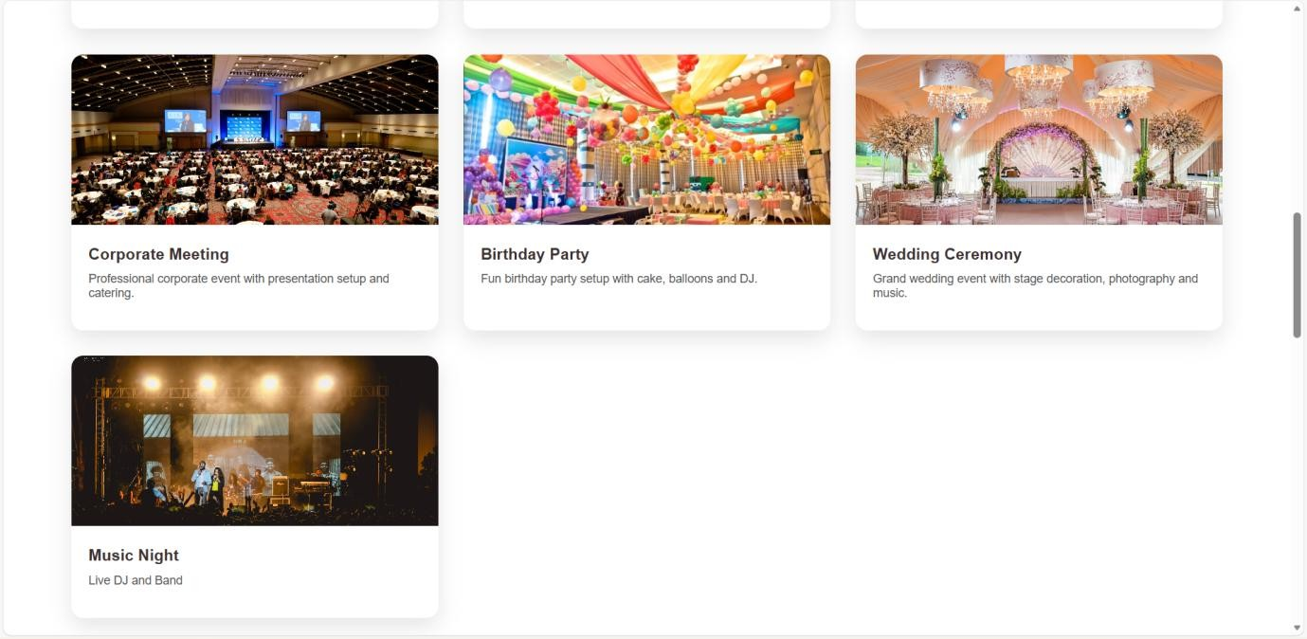
Recent Events :

    - Custom Events :

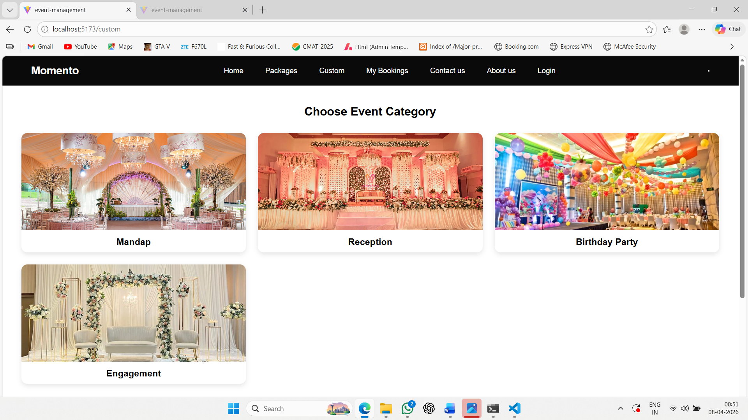

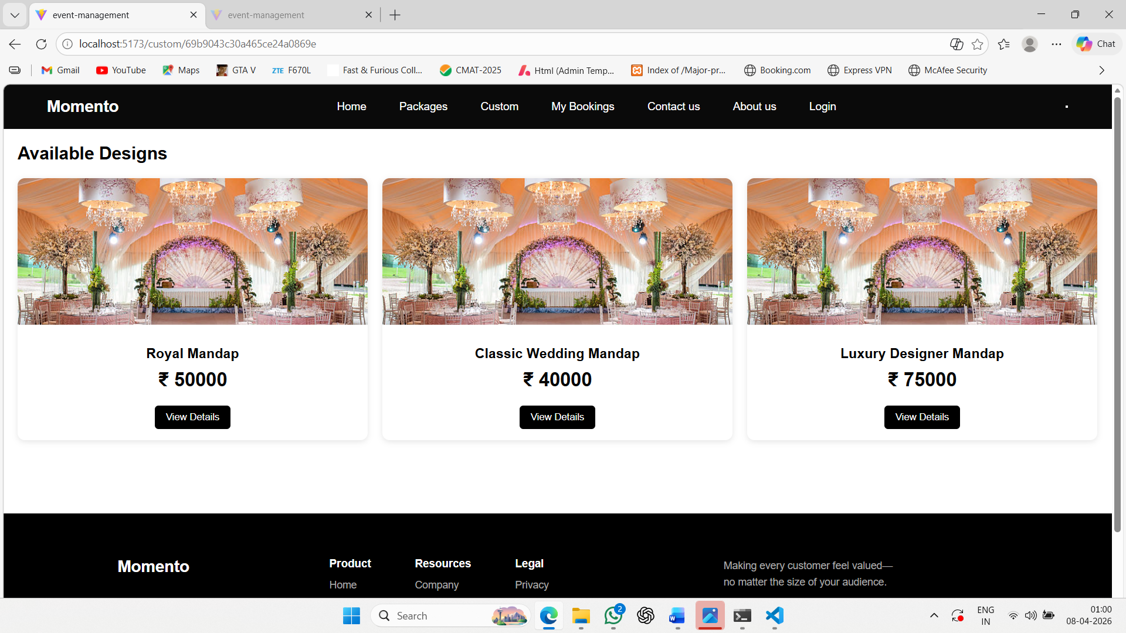
    - Product Detail :

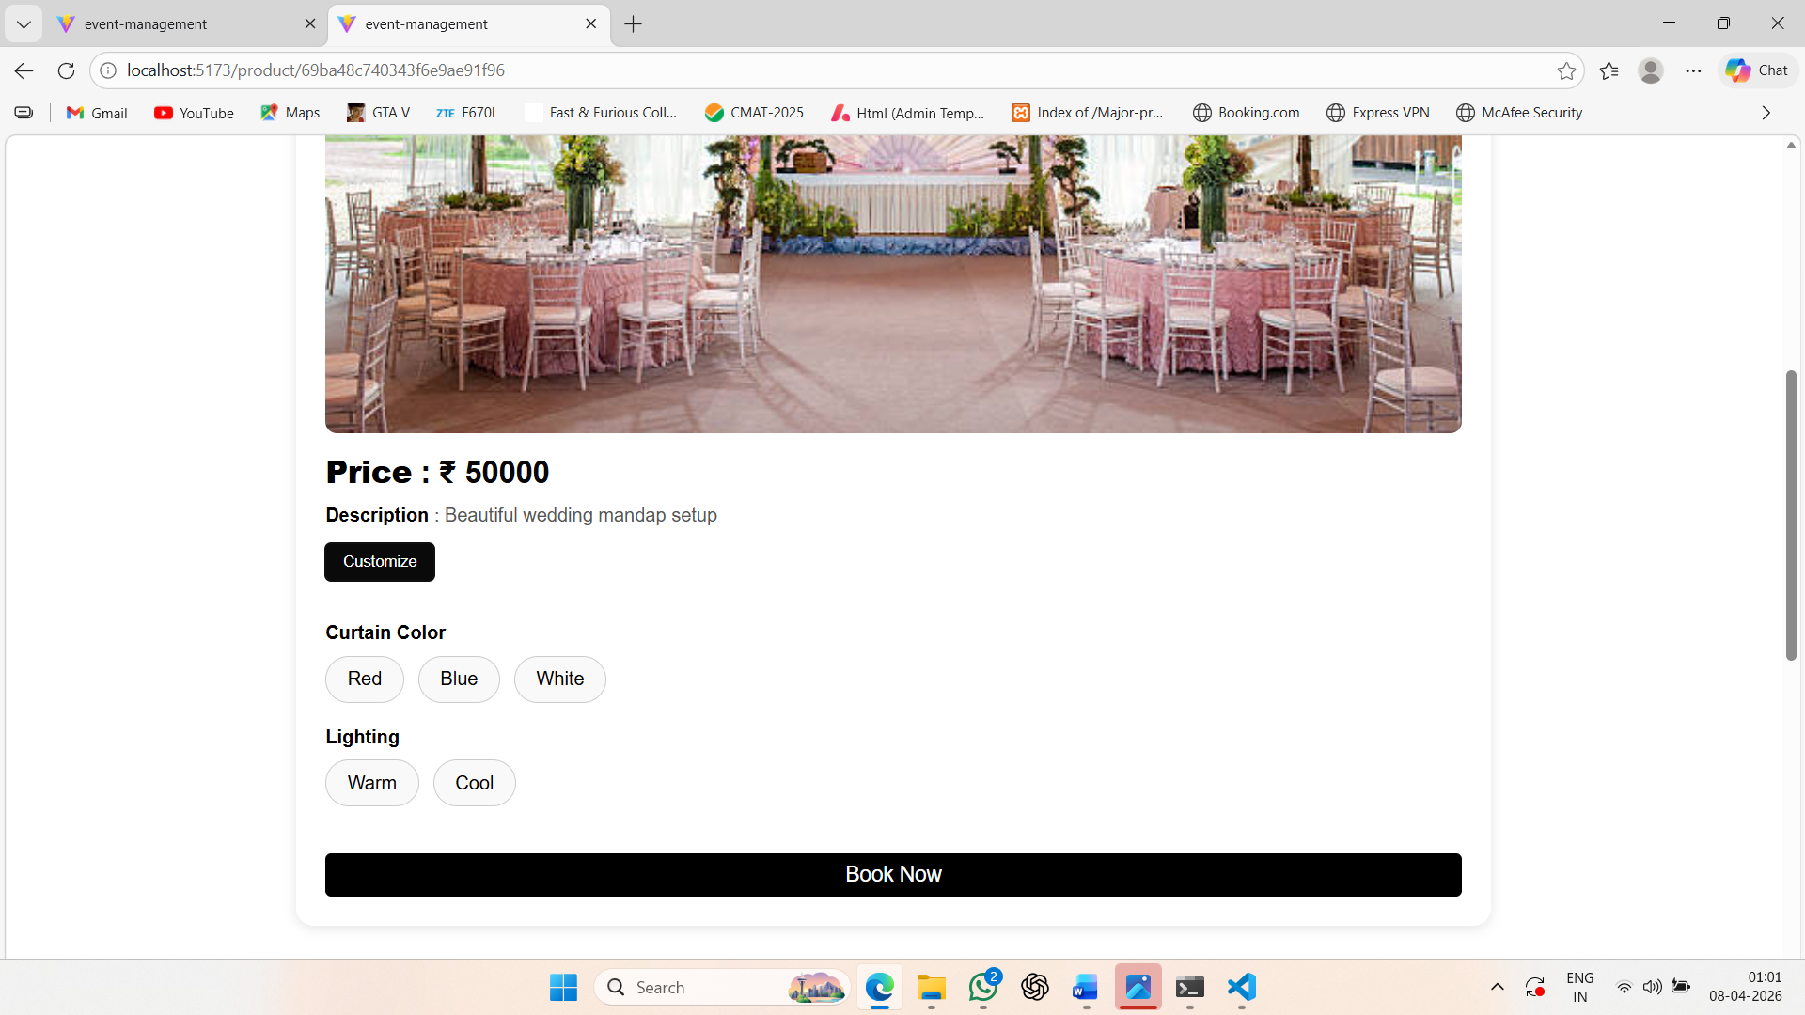

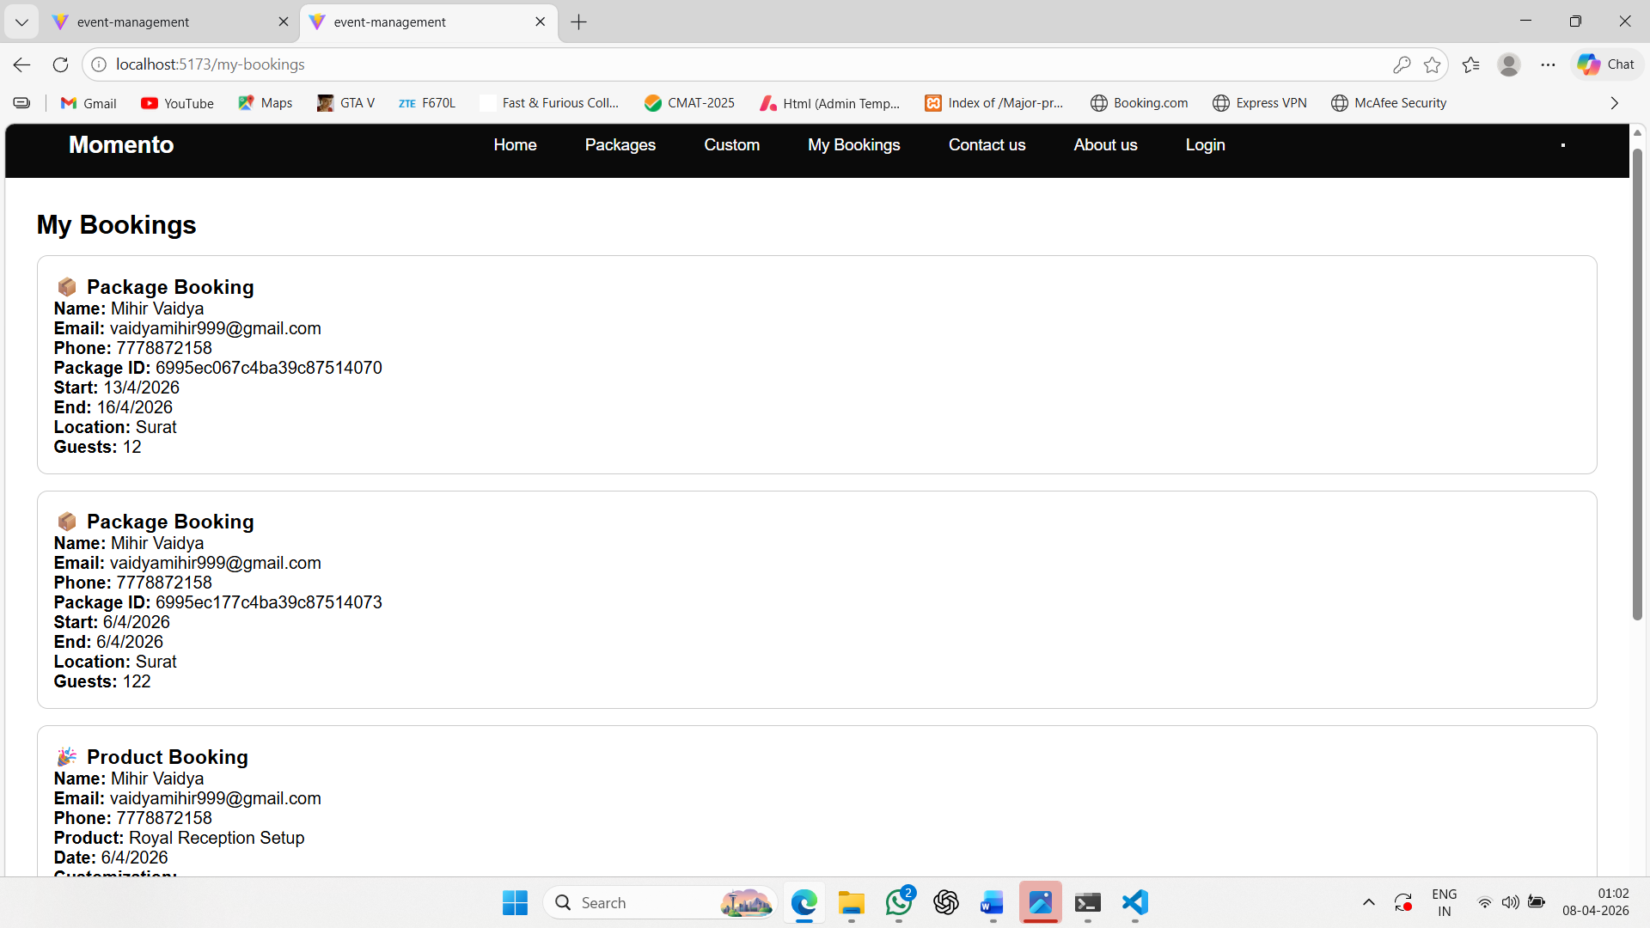
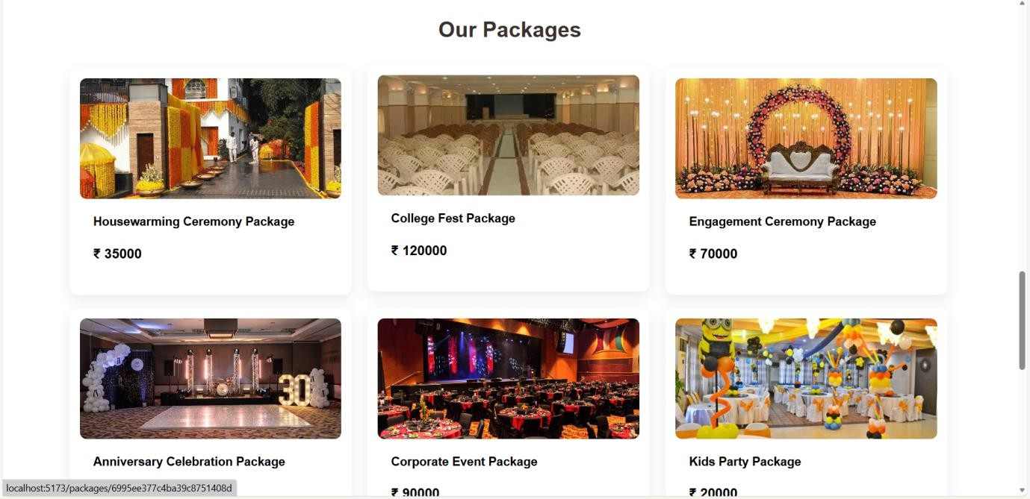
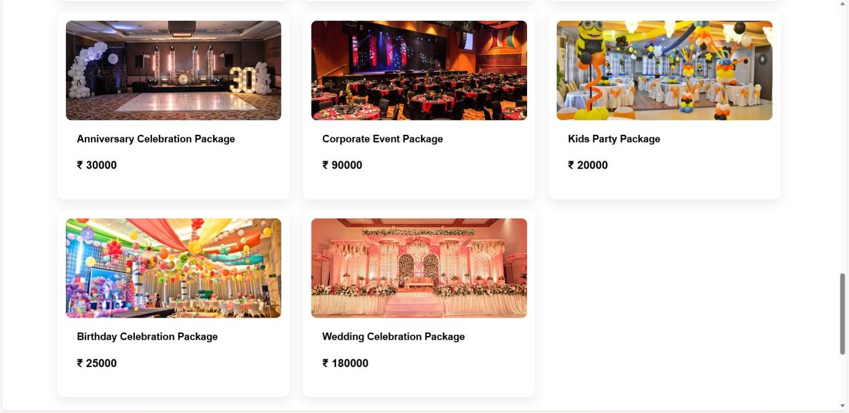
    - Package Display Page :

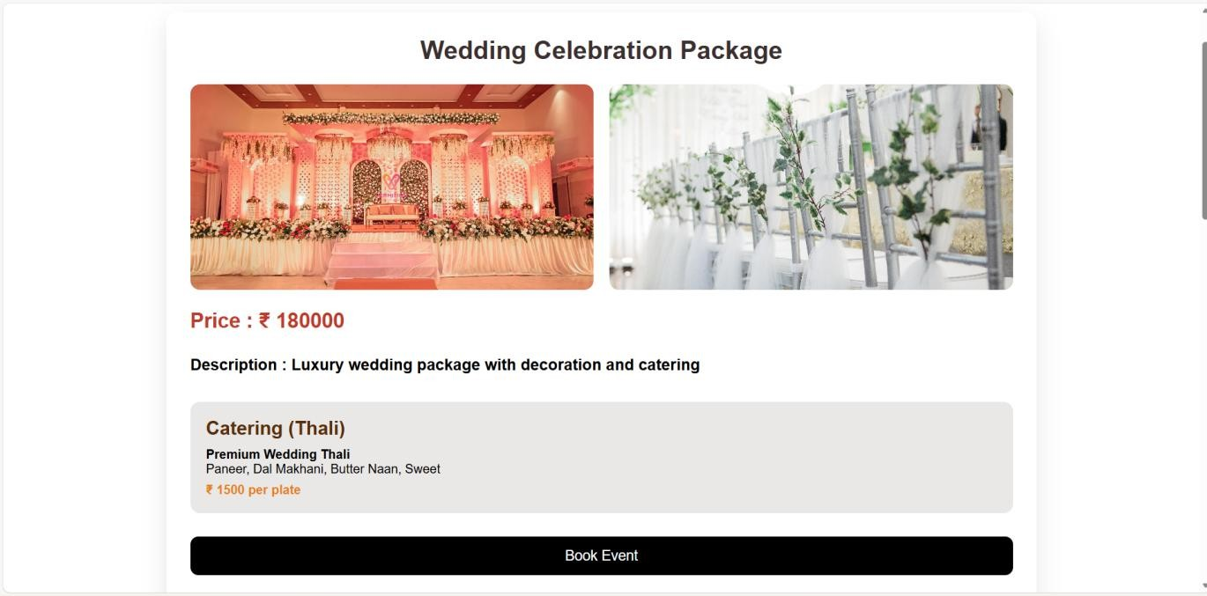
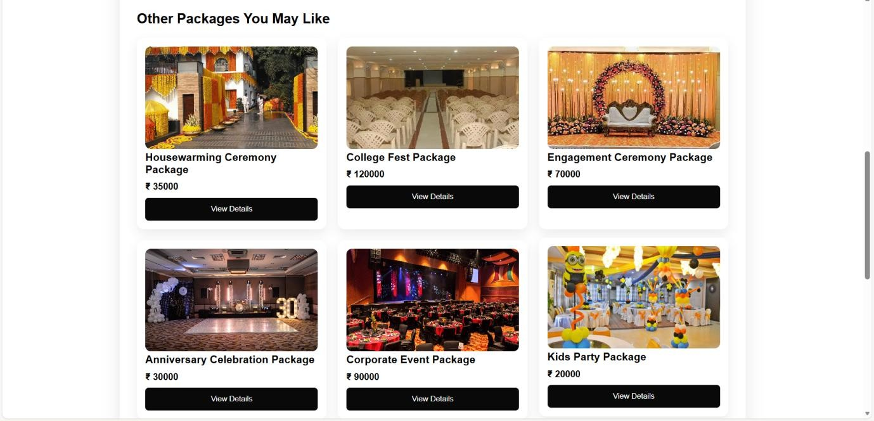
    - PackageDetail Page :

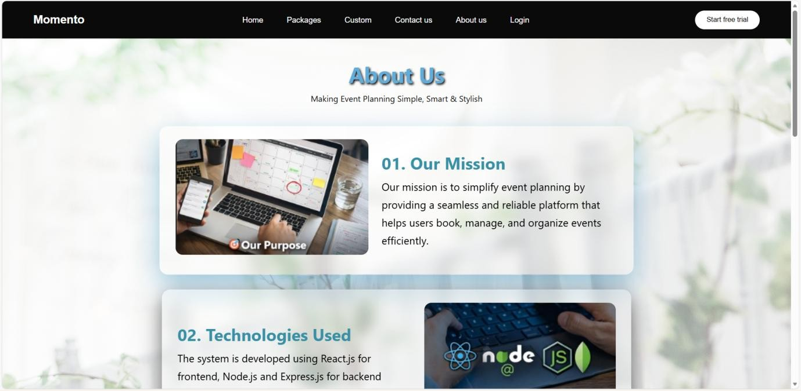
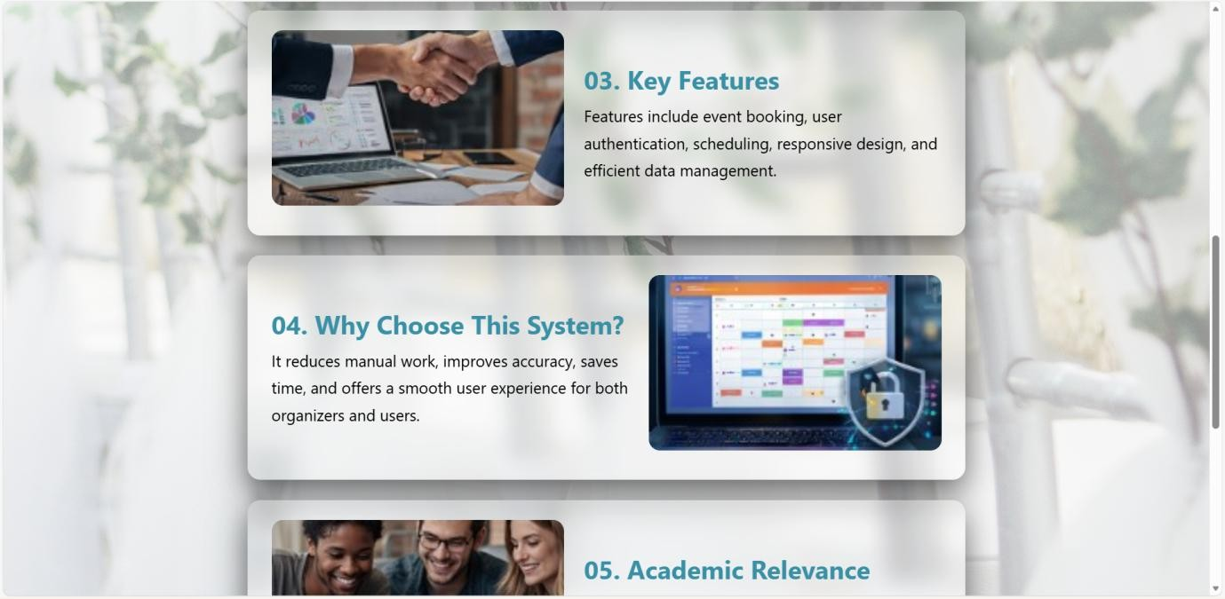
    - About Us Page :

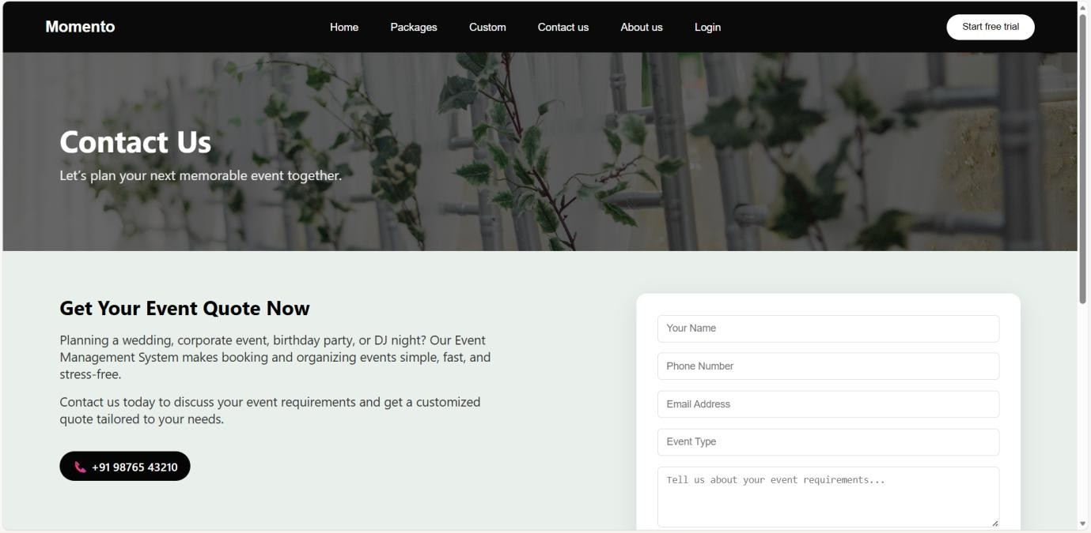
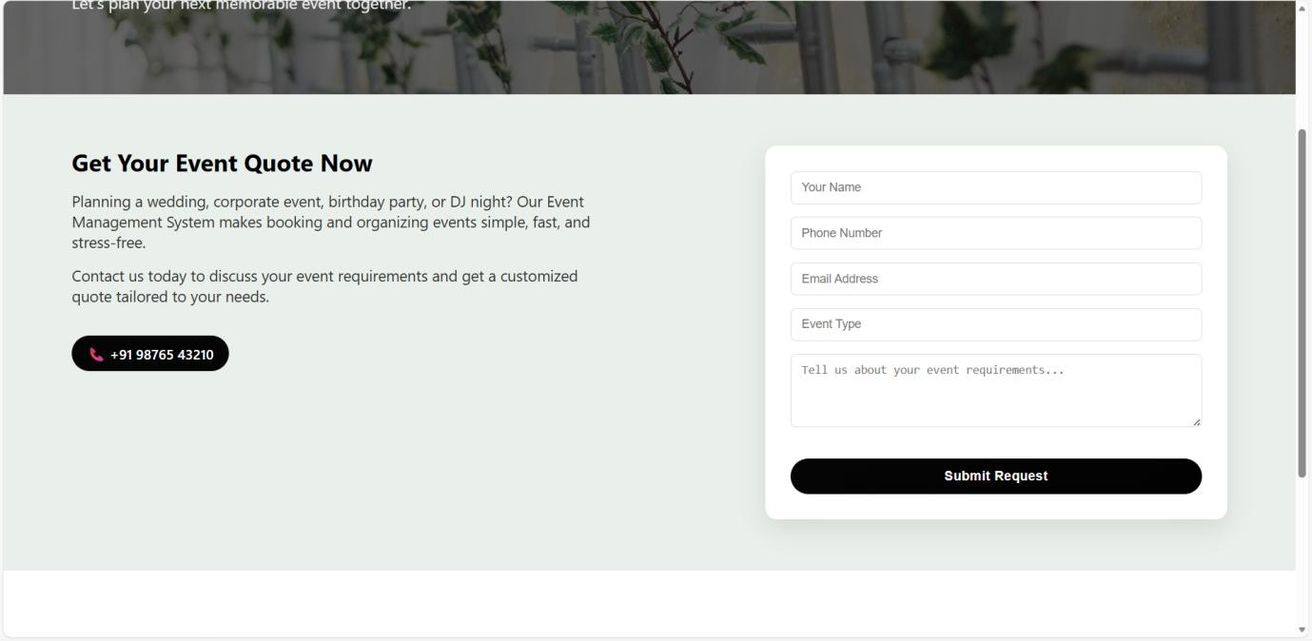
    - Contact Us Page :

    - Login Page :

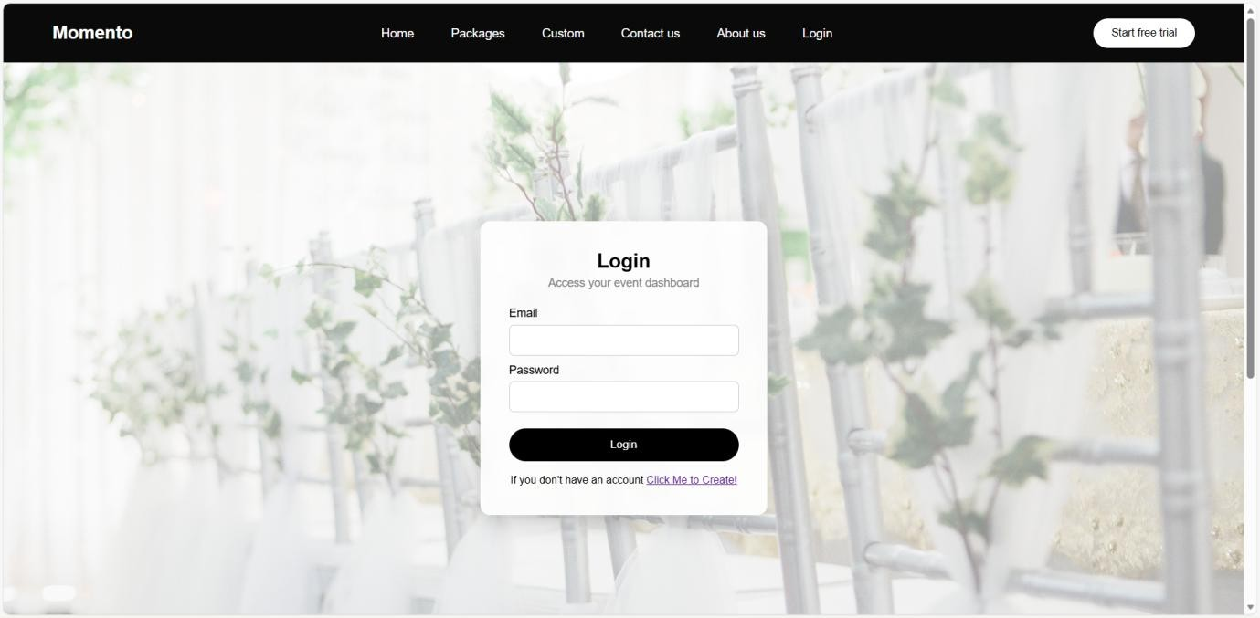
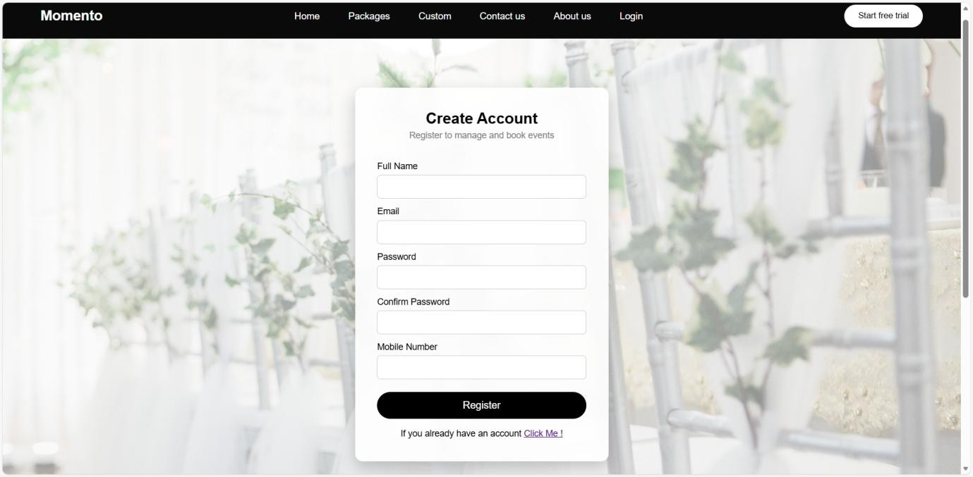

    - Register Page :

    - Admin Dashboard :

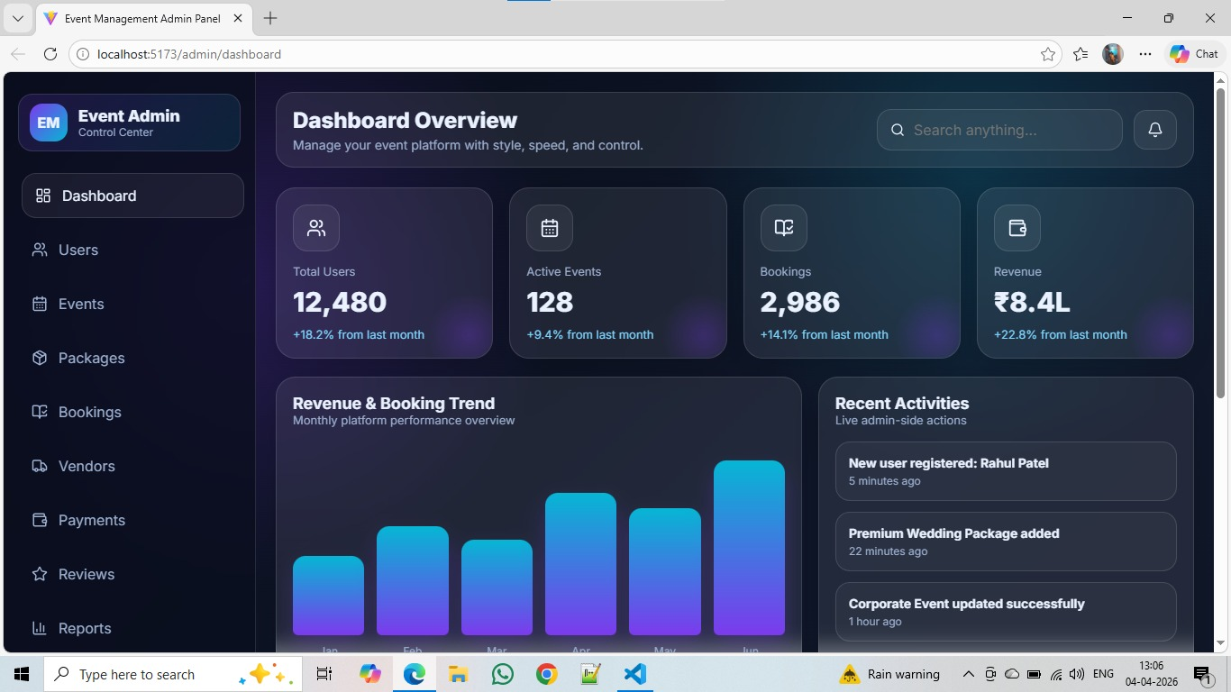

    - User:

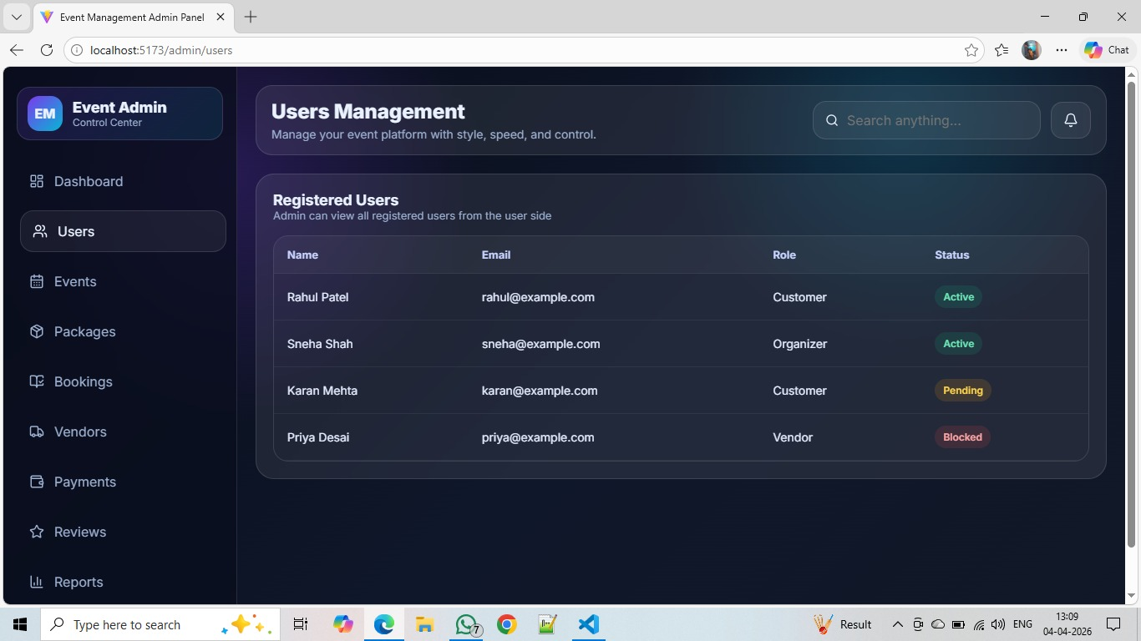
4.3.13 Add Events:

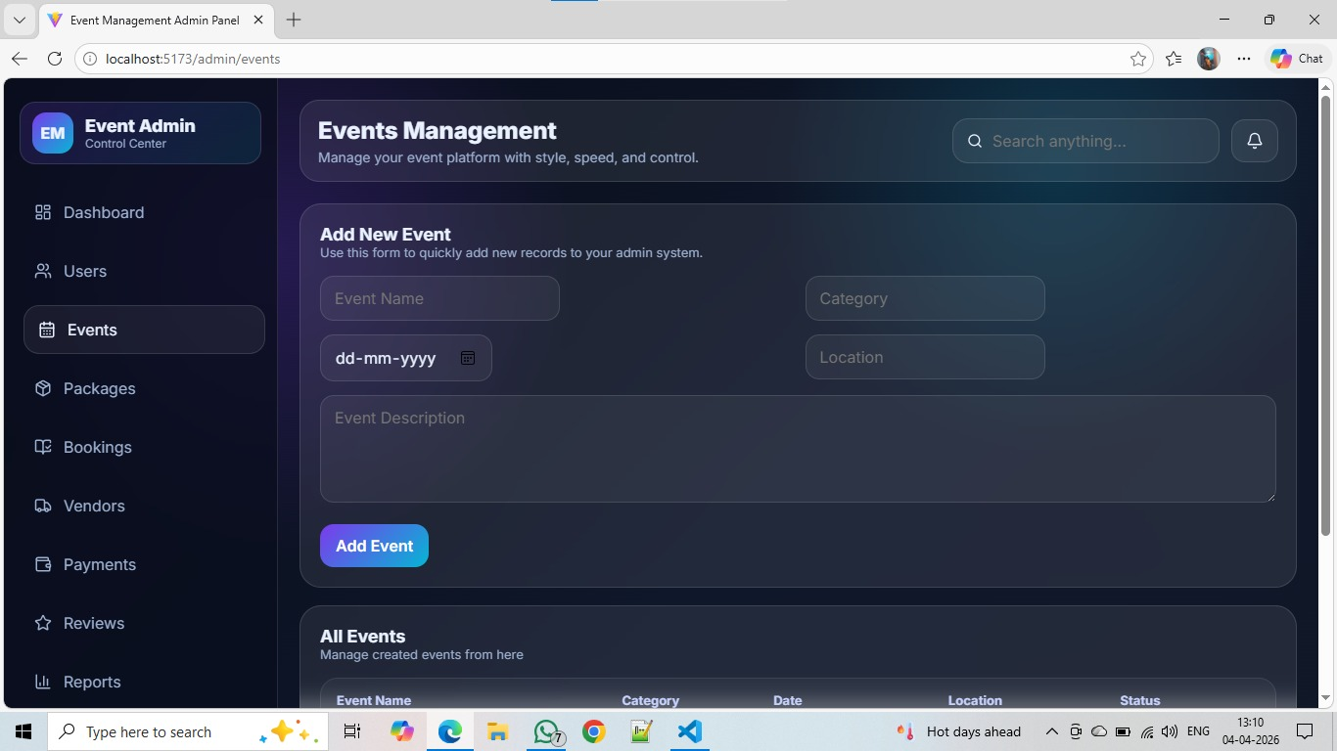

4.3.14 Add Packages:

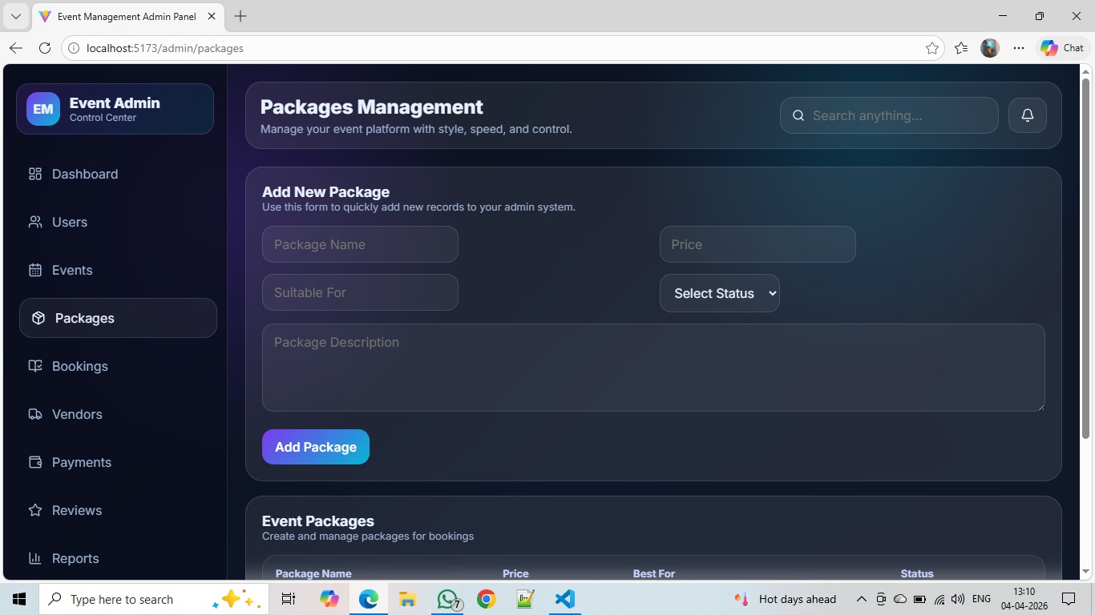

    - Show Booking:

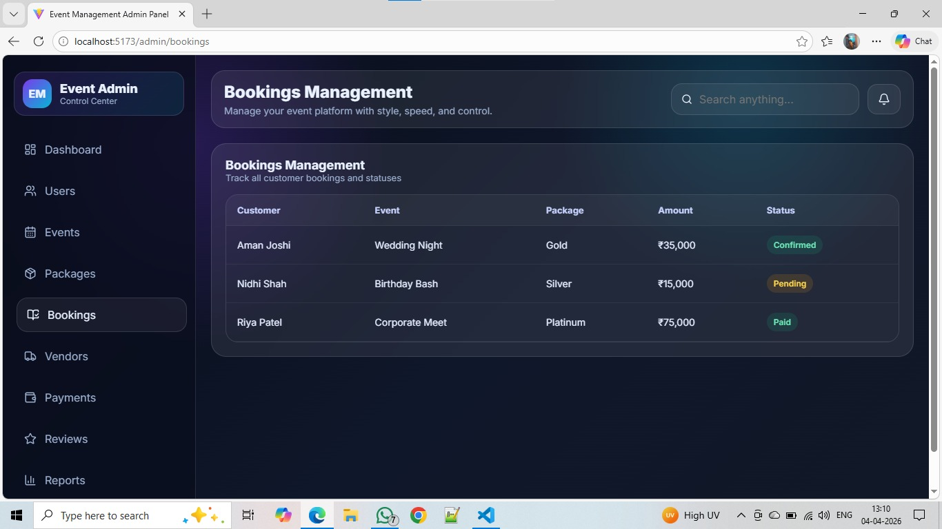

    - Show Payments Details:

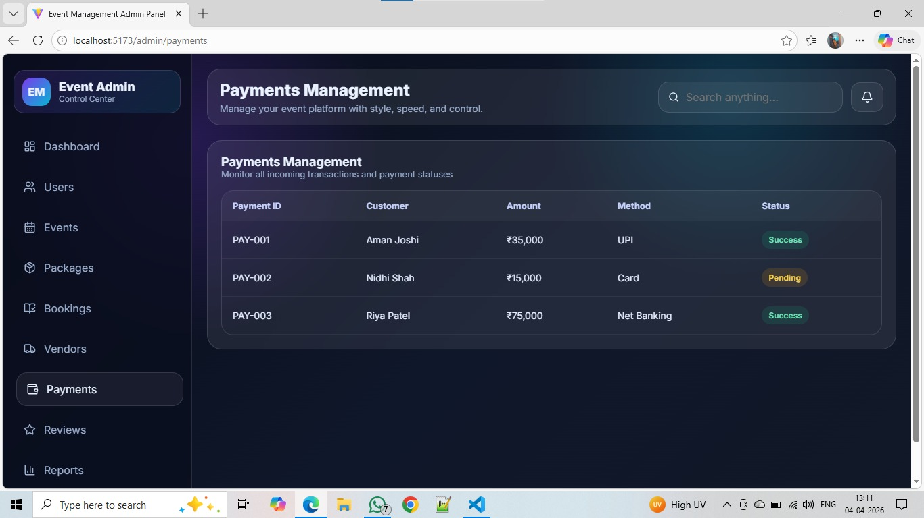

CHAPTER 5 – Future scope :

🔹 Payment Integration

Integrate online payment gateways like Razorpay / Stripe / PayPal

Allow users to pay booking amount securely

Generate payment receipts automatically

🔹 Mobile Application

Develop an Android/iOS mobile app

Provide better user experience and accessibility

Enable push notifications for bookings and updates

🔹 Real-time Notifications

Send SMS / Email confirmations after booking

Notify users about booking status, reminders, and offers

🔹 Admin Dashboard Enhancement

Advanced analytics (revenue, bookings, user activity)

Manage products, categories, and bookings efficiently

🔹 Review & Rating System

Users can give feedback on services/products

Improve service quality based on ratings

🔹 Live Availability Check

Show available dates for products/packages

Prevent double booking

🔹 Chat Support System

Add live chat between user and admin

Improve customer support

🔹 Multi-user Role System

Add roles like Admin, Vendor, User

Vendors can manage their own products/services

Chapter 6 - Learning During the Project Work

During the development of this project, several technical and practical skills were learned:

🔹 Technical Learning

Developed full-stack application using MERN Stack (MongoDB, Express, React, Node.js)

Learned how to create and manage REST APIs

Understood database design and schema modeling (MongoDB)

Implemented authentication using JWT (JSON Web Token)

Learned React Hooks (useState, useEffect, useNavigate, useParams)

Handled frontend-backend integration using Axios

Implemented dynamic UI with conditional rendering and state management

🔹 Problem Solving Skills

Debugged errors related to API, routing, and database

Fixed issues like data not displaying, incorrect API calls, etc.

Learned how to handle real-world project challenges

🔹 Design & UI Skills

Improved UI/UX using CSS

Designed responsive pages for better user experience

🔹 Project Management

Understood how to structure a full project (frontend + backend)

Learned step-by-step development approach

Improved logical thinking and planning

🔹 Real-world Understanding

Gained knowledge of how event booking systems work

Learned how customization and booking flows operate in real applications

